AI ASSISTED CODING Name: P.Pranay Hall Ticket No: 2303A51870 Batch:13

Assignment - 3.4 Task-1. Zero-shot Prompt – Fibonacci Series Generator
Task Description :
Without giving an example, write a single comment prompt asking GitHub Copilot to generate a Python function to print the first N Fibonacci numbers.

Prompt :
# Write a Python code that prints the first N Fibonacci numbers

Code
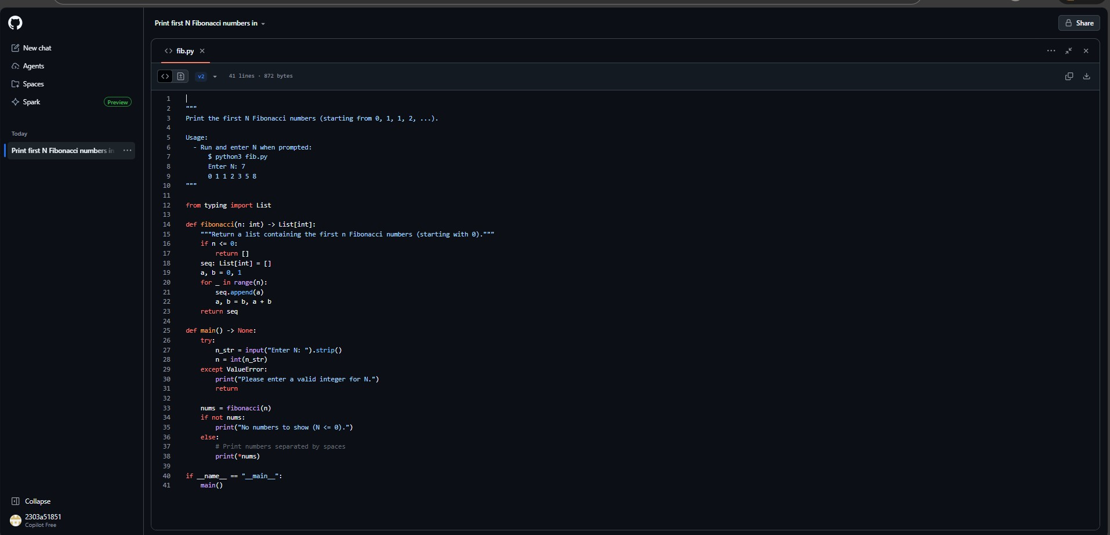
Out Put:
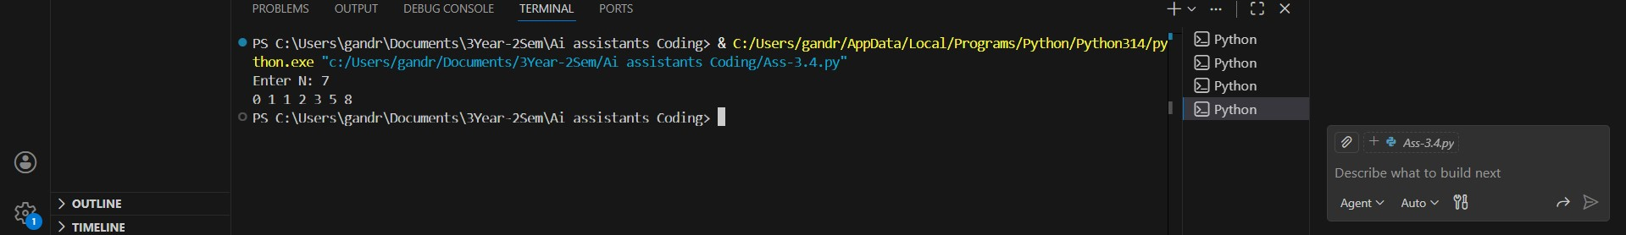 Justification:
In this task, Copilot was given only a single comment without any example. Despite the lack of context, it successfully generated a correct Fibonacci function, showing that zero-shot prompting works well for common and well-known problems. However, the logic was basic and depended entirely on Copilot’s prior training. This demonstrates that zero-shot prompts are effective for simple, standard tasks but may lack customization or optimization.

Task-2. One-shot Prompt – List Reversal Function
Task Description #2
• Write a comment prompt to reverse a list and provide one example below the comment to guide Copilot.

#Now Write a Python code for reverse a list Here Is the Example
Input:3,2,1 Out Put is 1,22,3
Code:
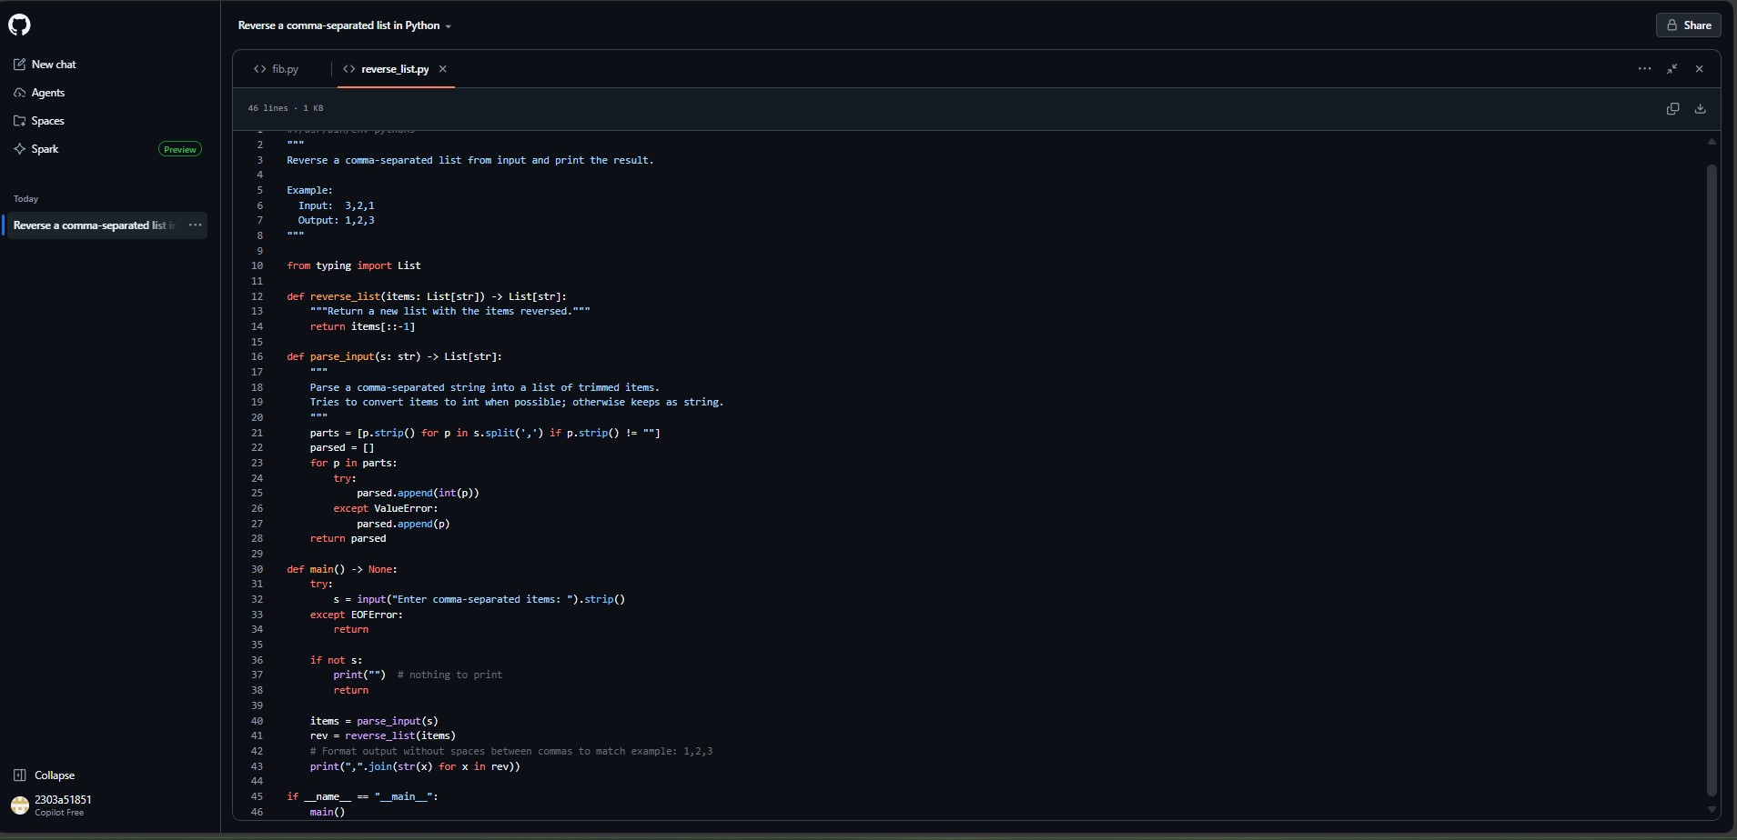
Output:
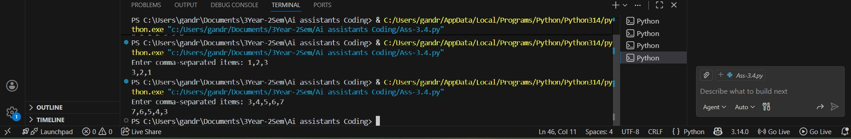

Justification:
By providing one example along with the comment, Copilot clearly understood the expected behavior of the function. The generated code accurately reversed the list using slicing or a loop. The example reduced ambiguity and improved correctness compared to a zero-shot approach. This shows that even a single example can significantly enhance output quality.

Task-3. Few-shot Prompt – String Pattern Matching
Task Description #3
• Write a comment with 2–3 examples to help Copilot understand
how to check if a string starts with a capital letter and ends with a period.

Prompt:
## Write a Python code that checks if a string starts with a capital letter and ends with a periodExample 1: # Input: "Hello world." # Output: True
# Example 2: # Input: "hello world." # Output: False # Example 3: #
Input: "Hello world" # Output: False
Code:
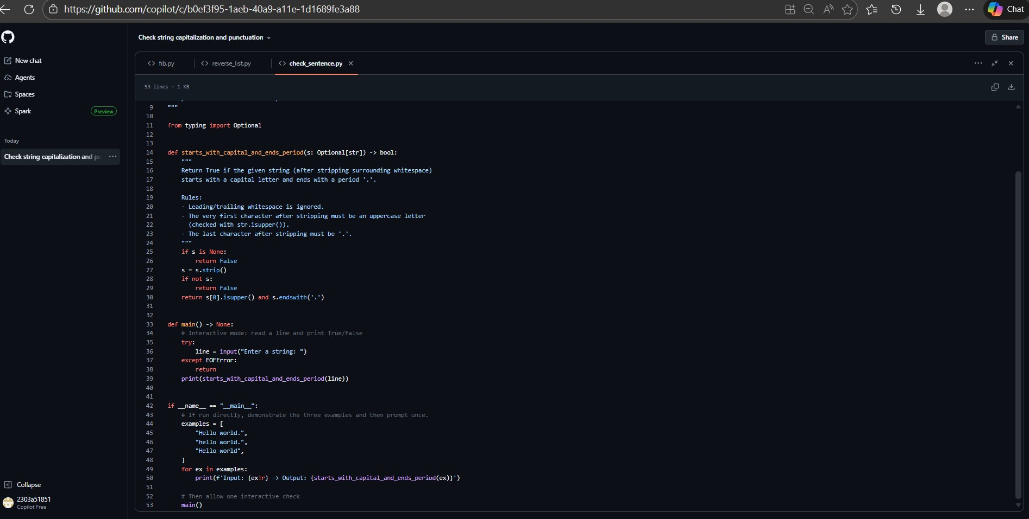
Output:
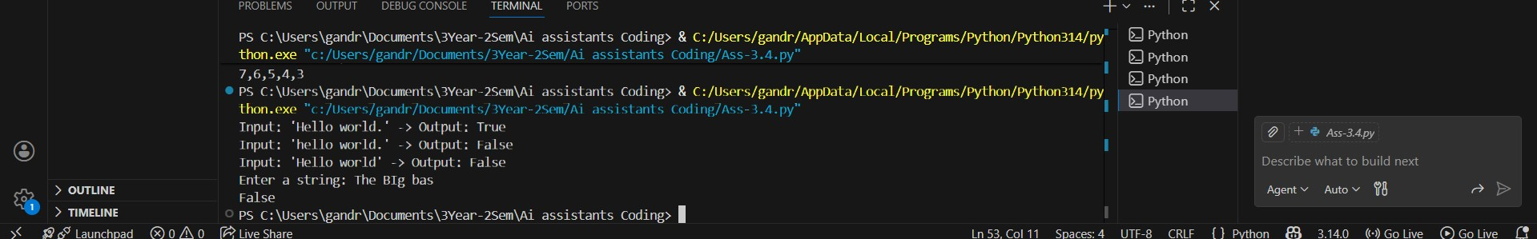
Justification:
With 2–3 examples, Copilot was able to identify the exact pattern requirements—starting with a capital letter and ending with a period. The generated is_valid() function was more precise and handled conditions correctly. Few-shot prompting guided Copilot to follow strict rules rather than guessing. This highlights how multiple examples help in pattern-based logic.

Task-4: Zero-shot vs Few-shot – Email Validator
Task Description #4
- First, prompt Copilot to write an email validation function using
zero-shot (just the task in comment).
- Then, rewrite the prompt using few-shot examples.

Prompt: Zero Short
# Write a Python function that validates if a string is a valid email address

Code:
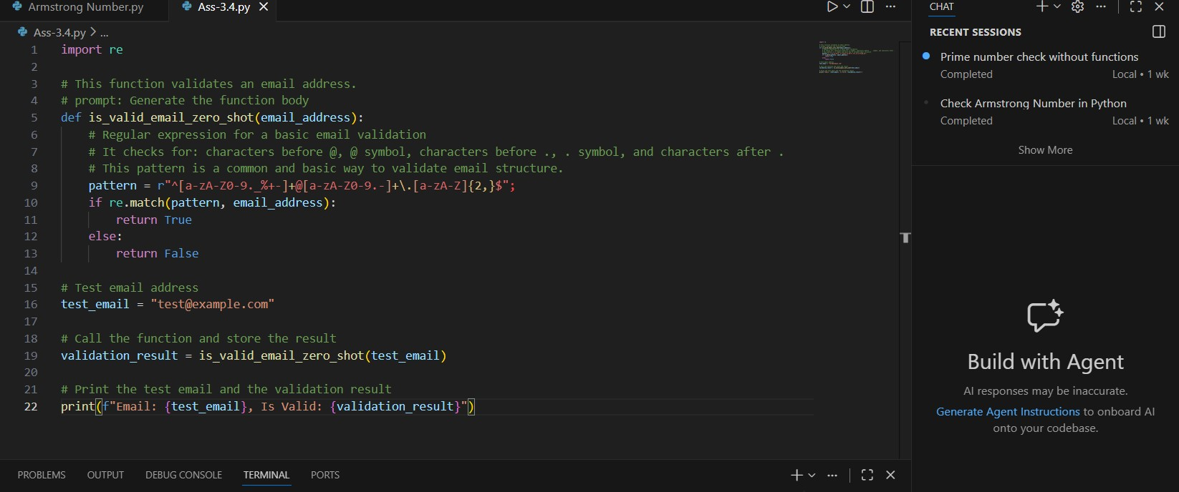
Output:
Code: Few -Short:
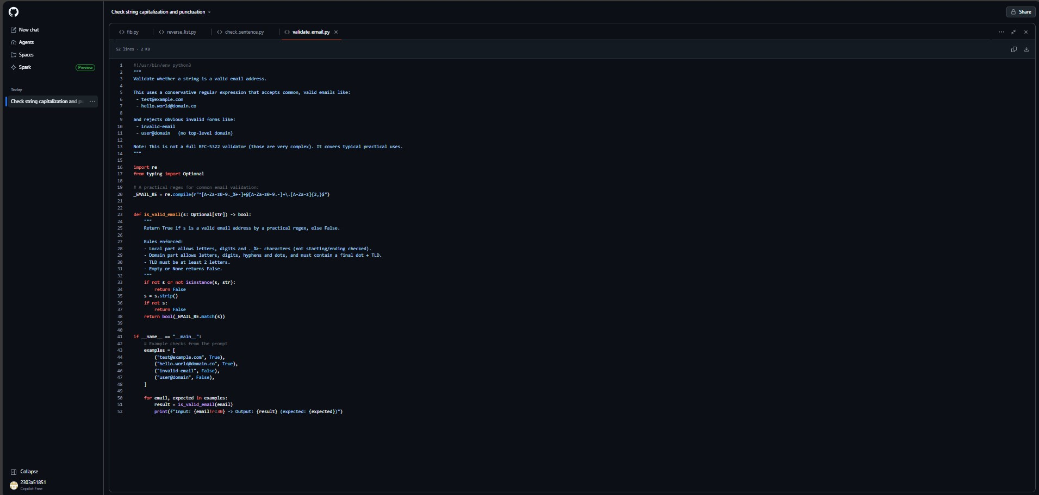
Out Put:
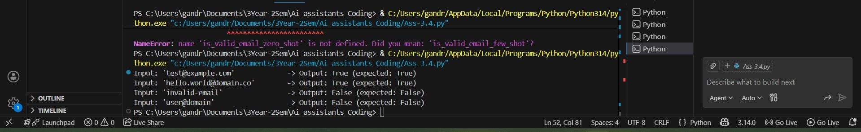
Justification:
The zero-shot prompt resulted in a simple email check with minimal validation logic. In contrast, the few-shot prompt produced a more robust function that checked for proper structure such as @ symbol and domain format. The comparison shows that few-shot prompting improves reliability and reduces logical gaps. Examples help Copilot understand edge cases better.
Task-5: Prompt Tuning – Summing Digits of a Number
Task Description #5
• Experiment with 2 different prompt styles to generate a function that returns the sum of digits of a number.
Style 1: Generic task prompt Style 2: Task + Input/Output example Code:
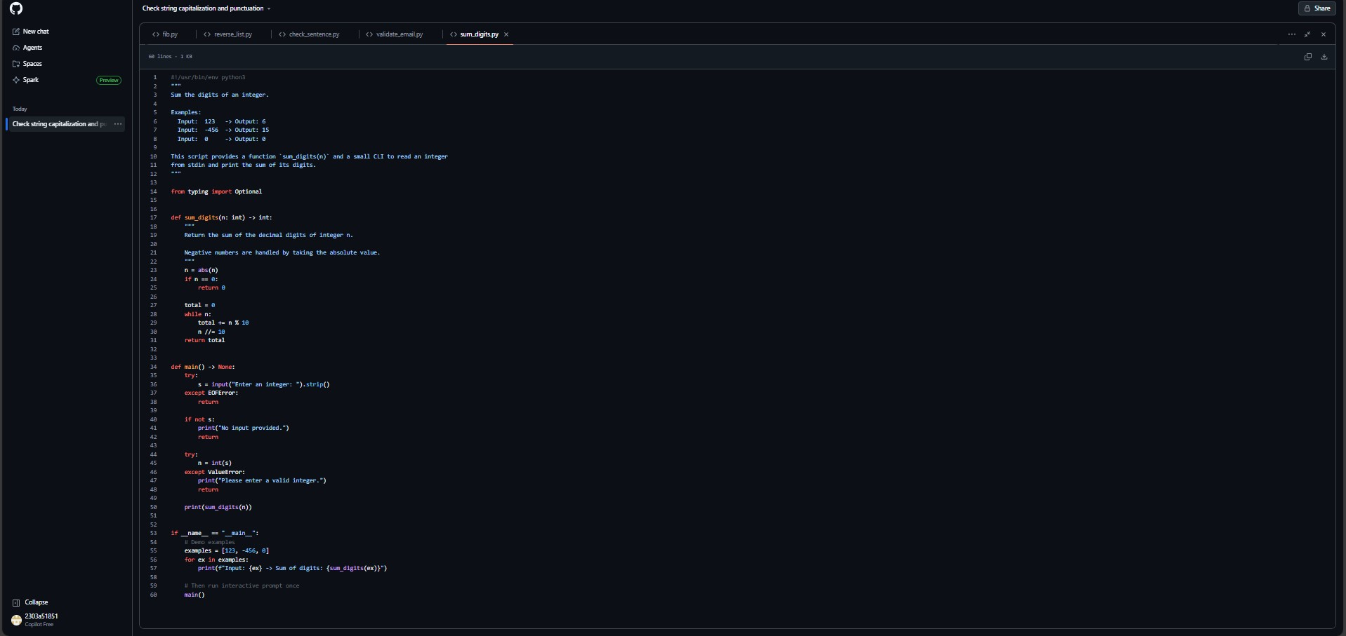
Out Put:
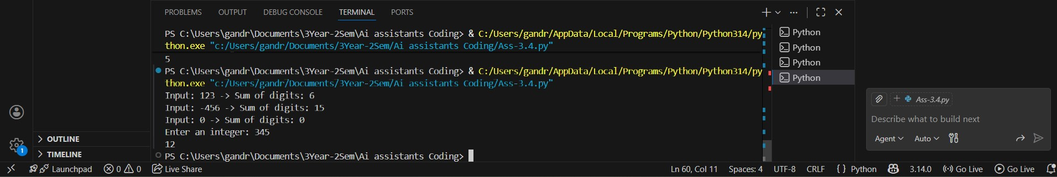

Prompt:
#Ok Now Write a Python code to Summing Digits of a NumberInput: 123 -> Sum of digits: 6 Input:
-456 -> Sum of digits: 15 Input: 0 -> Sum of digits:
0 Enter an integer: 345 12
Code:
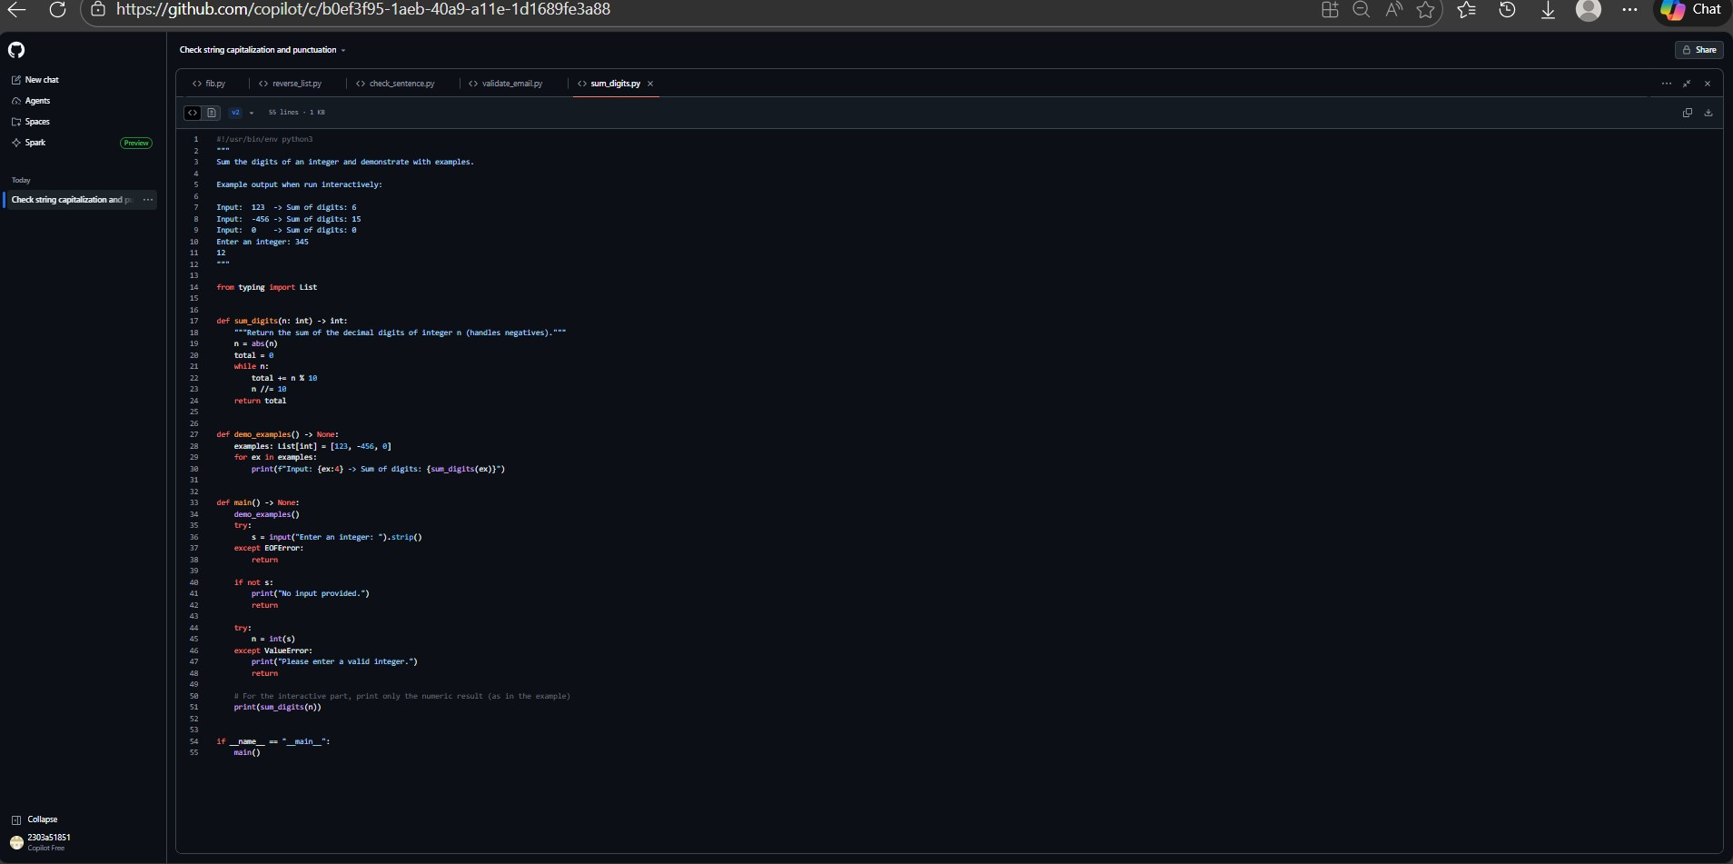
Out Put:

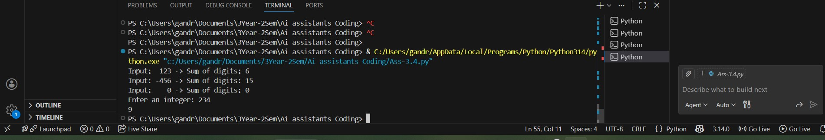

Justification:
The generic prompt generated a working but straightforward solution. When input/output examples were added, Copilot produced cleaner, more readable, and more accurate code. The example clarified expectations and improved function structure. This confirms that prompt tuning with examples leads to better-quality implementations.

